Q1. Identify the network portion and host portion for the following IP addresses based on the subnet mask given.

(i) 122.10.100.0/24 *(201705 TAR UC, resit)* (2 marks)

|  |  |
| --- | --- |
| Network Portion | Host Portion |
| 122.10.100 | .0 |

(ii) 180.80.0.0/16 *(201705 TAR UC, resit)* (2 marks)

|  |  |
| --- | --- |
| Network Portion | Host Portion |
| 180.80 | .0.0 |

Q2. Briefly describe each of the following in terms of Internet Protocol (IP) addresses.

1. Network address *(201705 TAR UC, resit)* (2 marks)

The address that is meant to identify a network, or a subnet/

1. Host address *(201705 TAR UC, resit)* (2 marks)

The address that is assigned to any host of interconnected network.

1. Broadcast address *(201705 TAR UC, resit)* (2 marks)

The address that used to communicate with other devices within the same local area network or subnet.

Q3. In an Internet Protocol version 4 (IPv4) network, the hosts can communicate in one of three different ways: Unicast, Broadcast, and Multicast. Illustrate these THREE (3) communication processes. *(201703 TAR UC, resit)* (6 marks)

For Unicast, the packet is sent on a one-to-one basis, no other hosts receive the message. For Broadcast, all devices receive the message. For Multicast, only certain devices in a “multicast group” receive the message.

Q4. Based on Figure 1, answer the following questions:

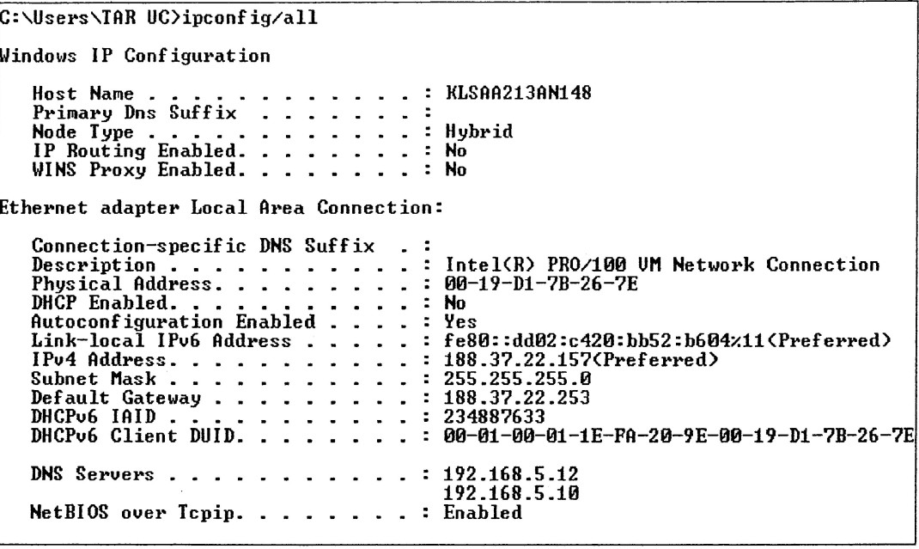

Figure 1: Windows IP Configuration

1. What is the name of this computer? *(201703 TAR UC, resit)* (1 mark)

KLSAA213AN148

1. Does this computer use static Internet Protocol (IP) version 4 address or dynamic IPv4 address? Explain your answer. *(201703 TAR UC, resit)* (3 marks)

Static Ipv4 address. The reason being DHCP is not enabled.

1. What is the Media Access Control (MAC) address of this computer?

*(201703 TAR UC, resit)* (1 mark)

00-19-D1-7B-26-7E

1. If the user wants to send data to 188.37.20.120/24 by using this computer, which device and the device interface’s IP address should the computer send to?

*(201703 TAR UC, resit)* (4 marks)

The Router, through the default gateway of 188.37.22.253

Q5. Compare unicast with broadcast IPv4 addresses in terms of their characteristics and uses.

*(201605 TAR UC, resit)* (6 marks)

Unicast – process of sending packets from one host to an individual host.

Broadcast – process of sending packet from one host to all host in network

Multicast – Process of sending packet from one host to selected group of hosts, possibly in different network

Q6. Define “private address” and give ONE (1) example of private address blocks.

*(201505 TAR UC, resit)* (3 marks)

These are blocks of addresses that are used in networks that require limited or no Internet access. These addresses are called private address.

Private addresses (any one of these examples)

10.0.0.0 to 10.255.255.255 (10.0.0.0/8)

172.16.0.0 to 172.31.255.255 (172.16.0.0/12)

192.168.0.0 to 192.168.255.255 (192.168.0.0/16)

Q7. Briefly explain the TWO (2) addresses in a network that cannot be assigned to a host.

*(201503 TAR UC, resit)* (4 marks)

The first (network address) and last (broadcast address) cannot be assigned to hosts.

Network address is the address by which we refer to the network.Broadcast address is a special address used to send data to all hosts in the networ

Q8. Outline the first octet range (decimal format) for Class A, B, C addresses.

*(201603 TAR UC, resit)* (6 marks)

|  |  |
| --- | --- |
| Class | First octet range |
| A | 1-127 |
| B | 128-191 |
| C | 192-223 |

Q9. Identify the address class and the default subnet mask of the following IP addresses.

(i) 192.168.10.10 *(201705 TAR UC, resit)* (2 marks)

|  |  |
| --- | --- |
| Address Class | Default Subnet Mask |
| C | 255.255.255.0 |

(ii) 172.16.5.5 *(201705 TAR UC, resit)* (2 marks)

|  |  |
| --- | --- |
| Address Class | Default Subnet Mask |
| B | 255.255.0.0 |

(iii) 10.10.10.10 *(201705 TAR UC, resit)* (2 marks)

|  |  |
| --- | --- |
| Address Class | Default Subnet Mask |
| A | 255.0.0.0 |

Q10. Convert the IPv4 address of 209.165.200.228/30 into binary IPv4 address and binary subnet mask respectively. *(201509 TAR UC, Main)* (4 marks)

|  |  |
| --- | --- |
| Binary IP address | 11010001 10100101 11001000 11100100 |
| Binary Subnet Mask | 11111111 11111111 11111111 11111100 |

Q11. Identify the class, default mask and network address for IPv4 address of 172.30.100.88.

*(201509 TAR UC, Main)* (3 marks)

|  |  |
| --- | --- |
| Class | B |
| Default mask | 255.255.0.0 |
| Network address | 172.30.0.0 |

Q12. Describe how a router uses the addressing field in an IP header to determine where to forward a packet. *(201409 TAR UC, Main)* (6 marks)

* The IPv4 destination address field contains the destination IP address of the host.
* The router uses the destination IP address and performs ANDing process to find the network address
* After this, the router checks its routing table to determine where to forward the packet.

Q13. Define what is classless addressing and state the importance of this addressing.

*(201703 TAR UC, resit)* (3 marks)

Classless addressing is the subnetting of subnets. The importance of this addressing is that it reduces the wastage of excess IP addresses.

Given answer: With classless addressing, address blocks that are appropriate to the number of hosts are assigned to companies or organizations without regards to the unicast class. Classful alocaton of address space wasted many availiability of IPv4 address.

Importance of classless addressing. Classless addressing plays an important role in overcoming IPv4 depletion.

Q14. Internet Protocol version 6 (IPv6) is designed to be the successor to Internet Protocol version 4 (IPv4). Briefly explain the need for UPv6 addressing. *(201703 TAR UC, resit)* (5marks)

IPv4 is running out of available public addresses. IPv6 has an address space far bigger than IPv4 and can support more public addresses compared to IPv4.

IPv4’s public addressing table is getting very big, slowing down the entire internet. IPv6 has less addresses than Ipv4, and has many performance enhancements, leading to higher overall performance even if IPv6 were to have the same amount of addresses as IPv4.

Q15. Describe TWO (2) types of migration techniques in order to support the coexistence of IPv4 and IPv6. *(201705 TAR UC, resit)* (6 marks)

Tunneling. Tunneling is a method of transporting an IPv6 packets over an IPv4 network. The IPv6 packet is encapsulated inside an IPv4 packet, similar to other types of data.

Dual-stack. Dual-stack is the process of running IPv6 and IPv4 concurrently. Devices on IPv6 can communicate with other Ipv6 devices. Devices on IPv4 can communicate with other IPv4 devices.

Q16. Write the compressed format for each of the following in terms of IPv6 address.

(i) 2001:0DF8:C090:0511:0000:0000:0008:A0C0 *(201705 TAR UC, resit)* (2 marks)

2001:DF8:C090:511:: 8:A0C0

(ii) 2001:00B3:0060:902A:0000:00C0:0000:0000 *(201705 TAR UC, resit)* (2 marks)

2001: B3: 60:902A:0: C0::

Q17. State THREE (3) types of Internet Protocol version 6 (IPv6) addresses.

*(201603 TAR UC, resit)* (3 marks)

Unicast Address. Multicast Address. Anycast address.

Q18. Briefly explain each of the following in terms of IPv6 unicast address.

1. Global unicast *(201705 TAR UC, resit)* (2 marks)

Unicast address that is globally unique, essentialy, a public IPv6 address.

1. Link-local *(201705 TAR UC, resit)* (2 marks)

Link local address are addresses that are unique only in the local area network. In a sense, they are private IPv6 addresses. They canot be routed.

1. Loopback *(201705 TAR UC, resit)* (2 marks)

Loopback address is the address used to refer to the host itself. It is often used for redirection.

1. Unspecified address *(201705 TAR UC, resit)* (2 marks)

Unspecified address is the the IP address to be used when the host is not yet assigned a public IPv6 address OR the source of the packet is not important.

1. Unique local *(201705 TAR UC, resit)* (2 marks)

Unique local address are local addresses that can be routed, but only within one routing domain.

Q19. State any TWO (2) Internet Control Message Protocol (ICMP) messages common to both ICMPv4 and ICMPv6. *(201503 TAR UC, resit)* (2 marks)

Host confirmation, time exceeded.

Q20. Based on the diagram illustrated in Figure 1-1, locate the directly connected routes and remote routes for R1. Use the template in Table 1-1 to present your answer.

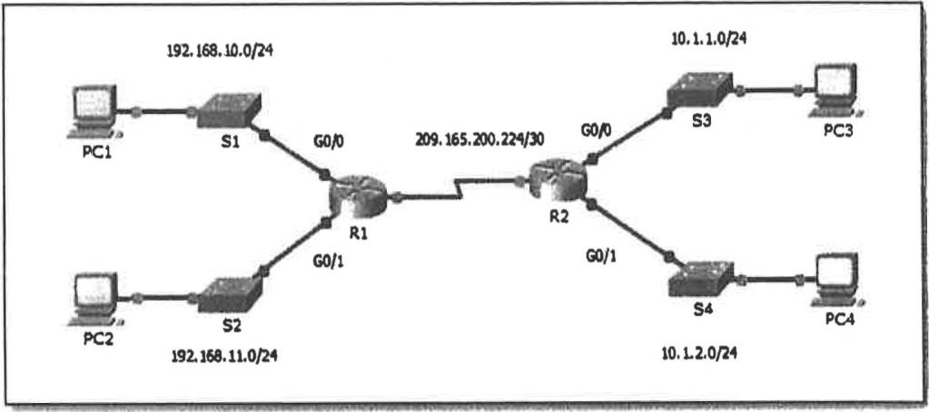

Figure 1-1: Network Topology Diagram Table 1-1 Network Addressing Table

(5 marks)

|  |  |  |
| --- | --- | --- |
|  | Directly Connected Routes | Remote Routes |
| RI | 192.168.10.0/24 | 10.1.1.0/24 |
| 192.168.11.0/24 | 10.1.2.0/24 |
| 209.165.200.224/30 |  |

Q21. Convert the following binary addresses to dotted decimal addresses and identify their classes. (i) 10101011 00011001 00110000 10100000 (2 marks)

171.25.48.160

(ii) 00011010 000-1110 01000111 11000000 (2 marks)

???

Q22. By applying Rule 1 and Rule 2 of IPv6 addressing, rewrite the following IPv6 addresses: (i) 2001 : OOCD : 0000 : 0100 : C301 : 09FO : 0000 : 0123 (2 marks)

2001 : OOCD : : 100 : C301 : 9FO : 0 : 123

(ii) FE80 : ODF6 : 902A : C090 : 0000 : 0512 : OOD4 : 0000 (2 marks)

FE80 : ODF6 : 902A : C090 : : 512 : OOD4 : 0

Q23. With reference to Figure 2, answer the following questions.

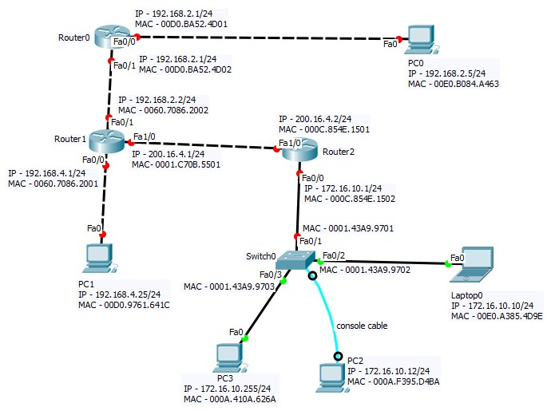

Figure 2: A Network Topology

1. How many networks shown in Figure 2? *(201605 TAR UC, resit)* (1 mark)

5 networks

1. “PC0 and PC2 are in the same network.” Do you agree with this statement? Justify your answer. *(201703 TAR UC, resit)* (3 marks)

No. This is because PC0 requires more than 1 hop to reach PC2.

1. Laptop0 is trying to ping PC2. What will be the expected result? Explain your answer.

*(201703 TAR UC, resit)* (3 marks)

Laptop0 will receive a reply. This is because PC2 is in the same network.

1. Laptop0 is trying to ping PC3. What will be the expected result? Explain your answer.

*(201703 TAR UC, resit)* (3 marks)

Laptop0 will not receive a reply. This is because PC3 is misconfigured with the broadcast address as the IP address.

Q24. Identify the address class and the default subnet mask of the following IP addresses.

(*201709 TAR UC main*)

(i) 192.14.6.0 (2 marks)

|  |  |
| --- | --- |
| **Address Class** | **Default Subnet Mask** |
| C | 255.0.0.0 |

(ii) 126.6.150.0 (2 marks)

|  |  |
| --- | --- |
| **Address Class** | **Default Subnet Mask** |
| C | 255.0.0.0 |

Q25. Give the compressed format for each of the following IPv6 addresses. (*201709 TAR UC main*) (i) 2345:0DB8:0000:6666:0000:0000:0000:0100 (2 marks)

2345:DB8:0:6666::100

(ii) 2345:0DB8:0350:2222:0F0A:0000:0000:0070 (2 marks)

2345:DB8:350:2222:F0A::70

(iii) 2345:ACAD:0001:0010:0000:0000:0000:0000 (2 marks)

2345:ACAD:1:10::